**Nama : Bagus Rizkita**

**Npm : 06.2017.1.06730**

**Langkah langkah pembuatan**

1. Buat Desain terlebih dahulu. Masukkan 2 komponen background worker.

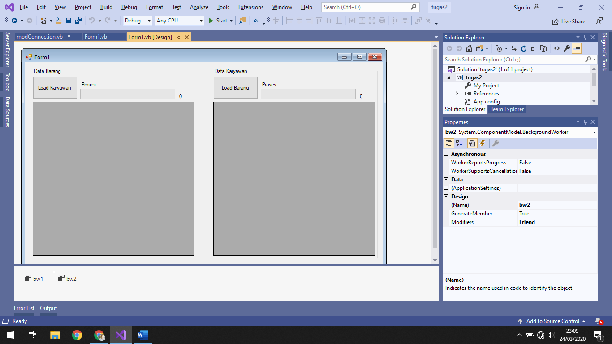

1. Setelah itu buat database phpMyAdmin.

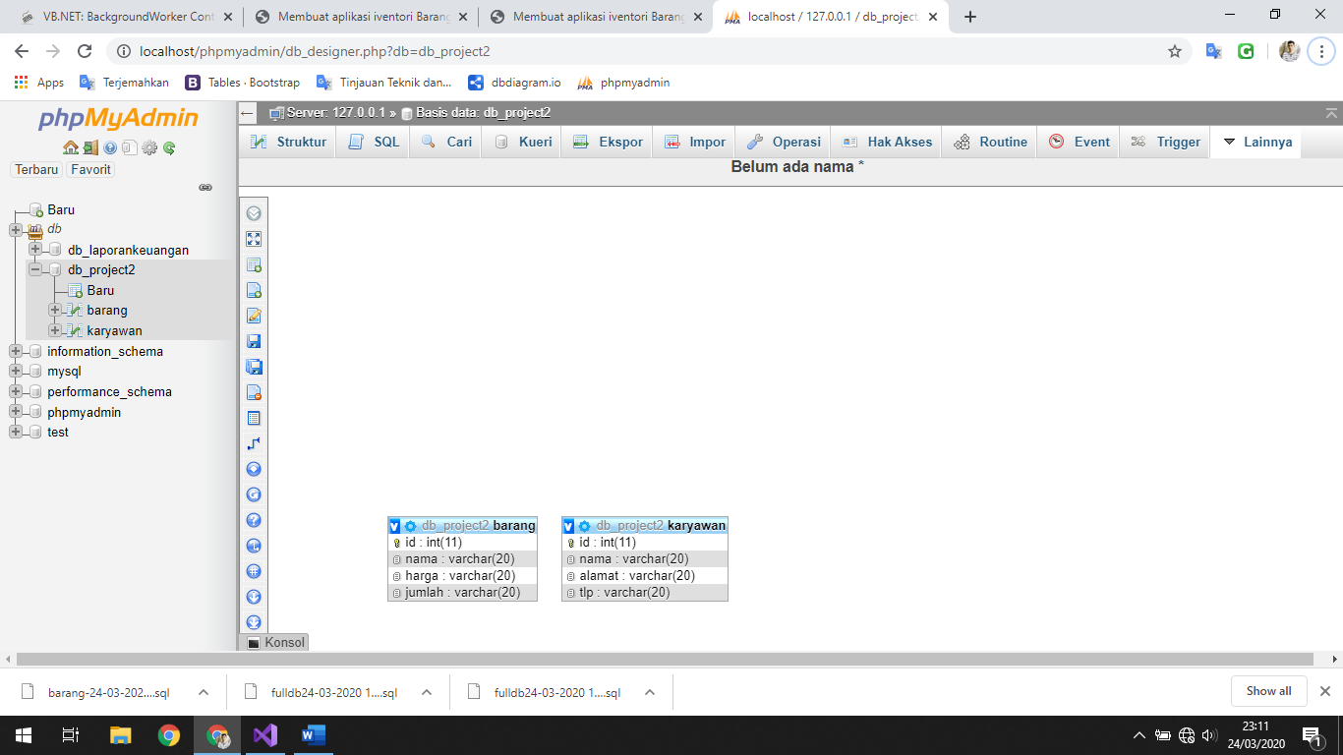

1. Tambahkan mysql connector. Terlebih dahulu harus menginstall plugin mysqlconnector. Setelah itu klik PROJECT > ADD REFERENCES > MYSQL.DATA
2. Setelah itu masukkan codingan di bawah ini untuk mengkoneksikan dengan mysql
3. Import tambahan yang di perlukan.

Imports MySql.Data.MySqlClient

Module modConnection

Public Conn As MySqlConnection

Public RD As MySqlDataReader

Public DA As MySqlDataAdapter

Public CMD As MySqlCommand

Public DS As DataSet

Public simpan, ubah, hapus As String

Public Sub bukaDB()

Dim SQLConn As String

SQLConn = "server=localhost;user id=root;password=;Database=db_project2"

Conn = New MySqlConnection(SQLConn)

If Conn.State = ConnectionState.Closed Then

Conn.Open()

End If

End Sub

End Module

Imports System.Threading

Imports MySql.Data.MySqlClient

Imports System.ComponentModel

1. Berikan pendeklarasian awal untuk memulai form1

Dim iMax As Integer = 5 'iterasi maksimal

Dim aMax As Integer = 5 'iterasi maksimal

Private Sub Form1_Load(sender As Object, e As EventArgs) Handles Me.Load

'untuk mencegah error saat background proses mengubah UI

Control.CheckForIllegalCrossThreadCalls = False

With bw1

.WorkerReportsProgress = True 'catat nilai progress

.WorkerSupportsCancellation = True 'supaya bisa cancel

End With

With bw2

.WorkerReportsProgress = True 'catat nilai progress

.WorkerSupportsCancellation = True 'supaya bisa cancel

End With

'setting nilai maksimum progress bar

ProgressBar1.Maximum = iMax

ProgressBar2.Maximum = aMax

End Sub

1. Buat method untuk memanggil data.
2. Berikan action pada tombol

Private Sub btnBarang_Click(sender As Object, e As EventArgs) Handles btnBarang.Click

bw2.RunWorkerAsync()

End Sub

Private Sub btnKaryawan_Click(sender As Object, e As EventArgs) Handles btnKaryawan.Click

bw1.RunWorkerAsync()

End Sub

Sub DataKaryawan()

Call bukaDB()

DA = New MySqlDataAdapter("SELECT * FROM karyawan", Conn)

DS = New DataSet

DA.Fill(DS, "karyawan")

DataGridView1.DataSource = DS.Tables("karyawan")

DataGridView1.ReadOnly = True

End Sub

Sub DataBarang()

Call bukaDB()

DA = New MySqlDataAdapter("SELECT * FROM barang", Conn)

DS = New DataSet

DA.Fill(DS, "barang")

DataGridView2.DataSource = DS.Tables("barang")

DataGridView2.ReadOnly = True

End Sub

1. Buat aksi untuk background Worker

Private Sub bw1_DoWork(sender As Object, e As System.ComponentModel.DoWorkEventArgs) Handles bw1.DoWork

For i = 0 To iMax

'handle jika ada cancel

If bw1.CancellationPending = True Then

e.Cancel = True

Exit For

Else

'proses normal tanpa cancel

lblProgres1.Text = i 'menampilkan iterasi ke pada textbox

'mengirim progress iterasi

bw1.ReportProgress(i)

'supaya proses berhenti sejenak 1000 milidetik = 1 detik

System.Threading.Thread.Sleep(1000)

End If

Next

End Sub

Private Sub bw1_ProgressChanged(sender As Object,

e As ProgressChangedEventArgs) _

Handles bw1.ProgressChanged

ProgressBar1.Value = e.ProgressPercentage

End Sub

Private Sub bw1_RunWorkerCompleted(sender As Object,

e As RunWorkerCompletedEventArgs) _

Handles bw1.RunWorkerCompleted

MsgBox("Proses Data Karyawan Selesai")

Call DataKaryawan()

End Sub

1. Untuk background worker 2

Private Sub bw2_DoWork(sender As Object, e As DoWorkEventArgs) Handles bw2.DoWork

For a = 0 To aMax

'handle jika ada cancel

If bw2.CancellationPending = True Then

e.Cancel = True

Exit For

Else

'proses normal tanpa cancel

lblProgres2.Text = a 'menampilkan iterasi ke pada textbox

'mengirim progress iterasi

bw2.ReportProgress(a)

'supaya proses berhenti sejenak 1000 milidetik = 1 detik

System.Threading.Thread.Sleep(1000)

End If

Next

End Sub

Private Sub bw2_ProgressChanged(sender As Object,

e As ProgressChangedEventArgs) _

Handles bw2.ProgressChanged

ProgressBar2.Value = e.ProgressPercentage

End Sub

Private Sub bw2_RunWorkerCompleted(sender As Object,

e As RunWorkerCompletedEventArgs) _

Handles bw2.RunWorkerCompleted

MsgBox("Proses Data Barang Selesai")

Call DataBarang()

End Sub

End Class

Hasil Software :

